6A^{th} Grade: Unit 14, Lesson 9

- What inequality is represented by the graph below?
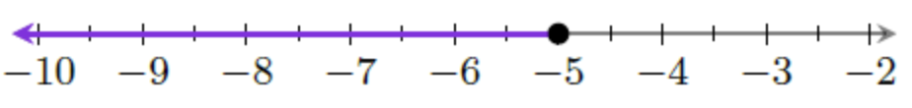

$$y≤-5$$

- What is the maximum value for $x$ in the inequality $x≤19$?

19

- What is a possible value that is in the solution set for the inequality $y<4$?

-5, -2, 0, 3 are all possible values

- What step do you have to take to solve the inequality $x+2.3≤5.5$?

Subtract both sides by 2.3 to isolate the x value

- What is the inequality represented by the following graph?
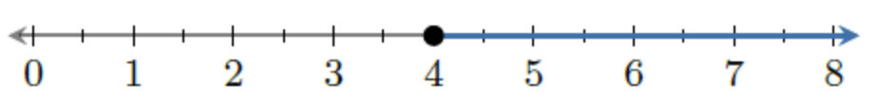

$$4≤x$$

- Describe the graph for the inequality $x>1$ on the number line.

A hollow dot at 1 with an arrow going right

